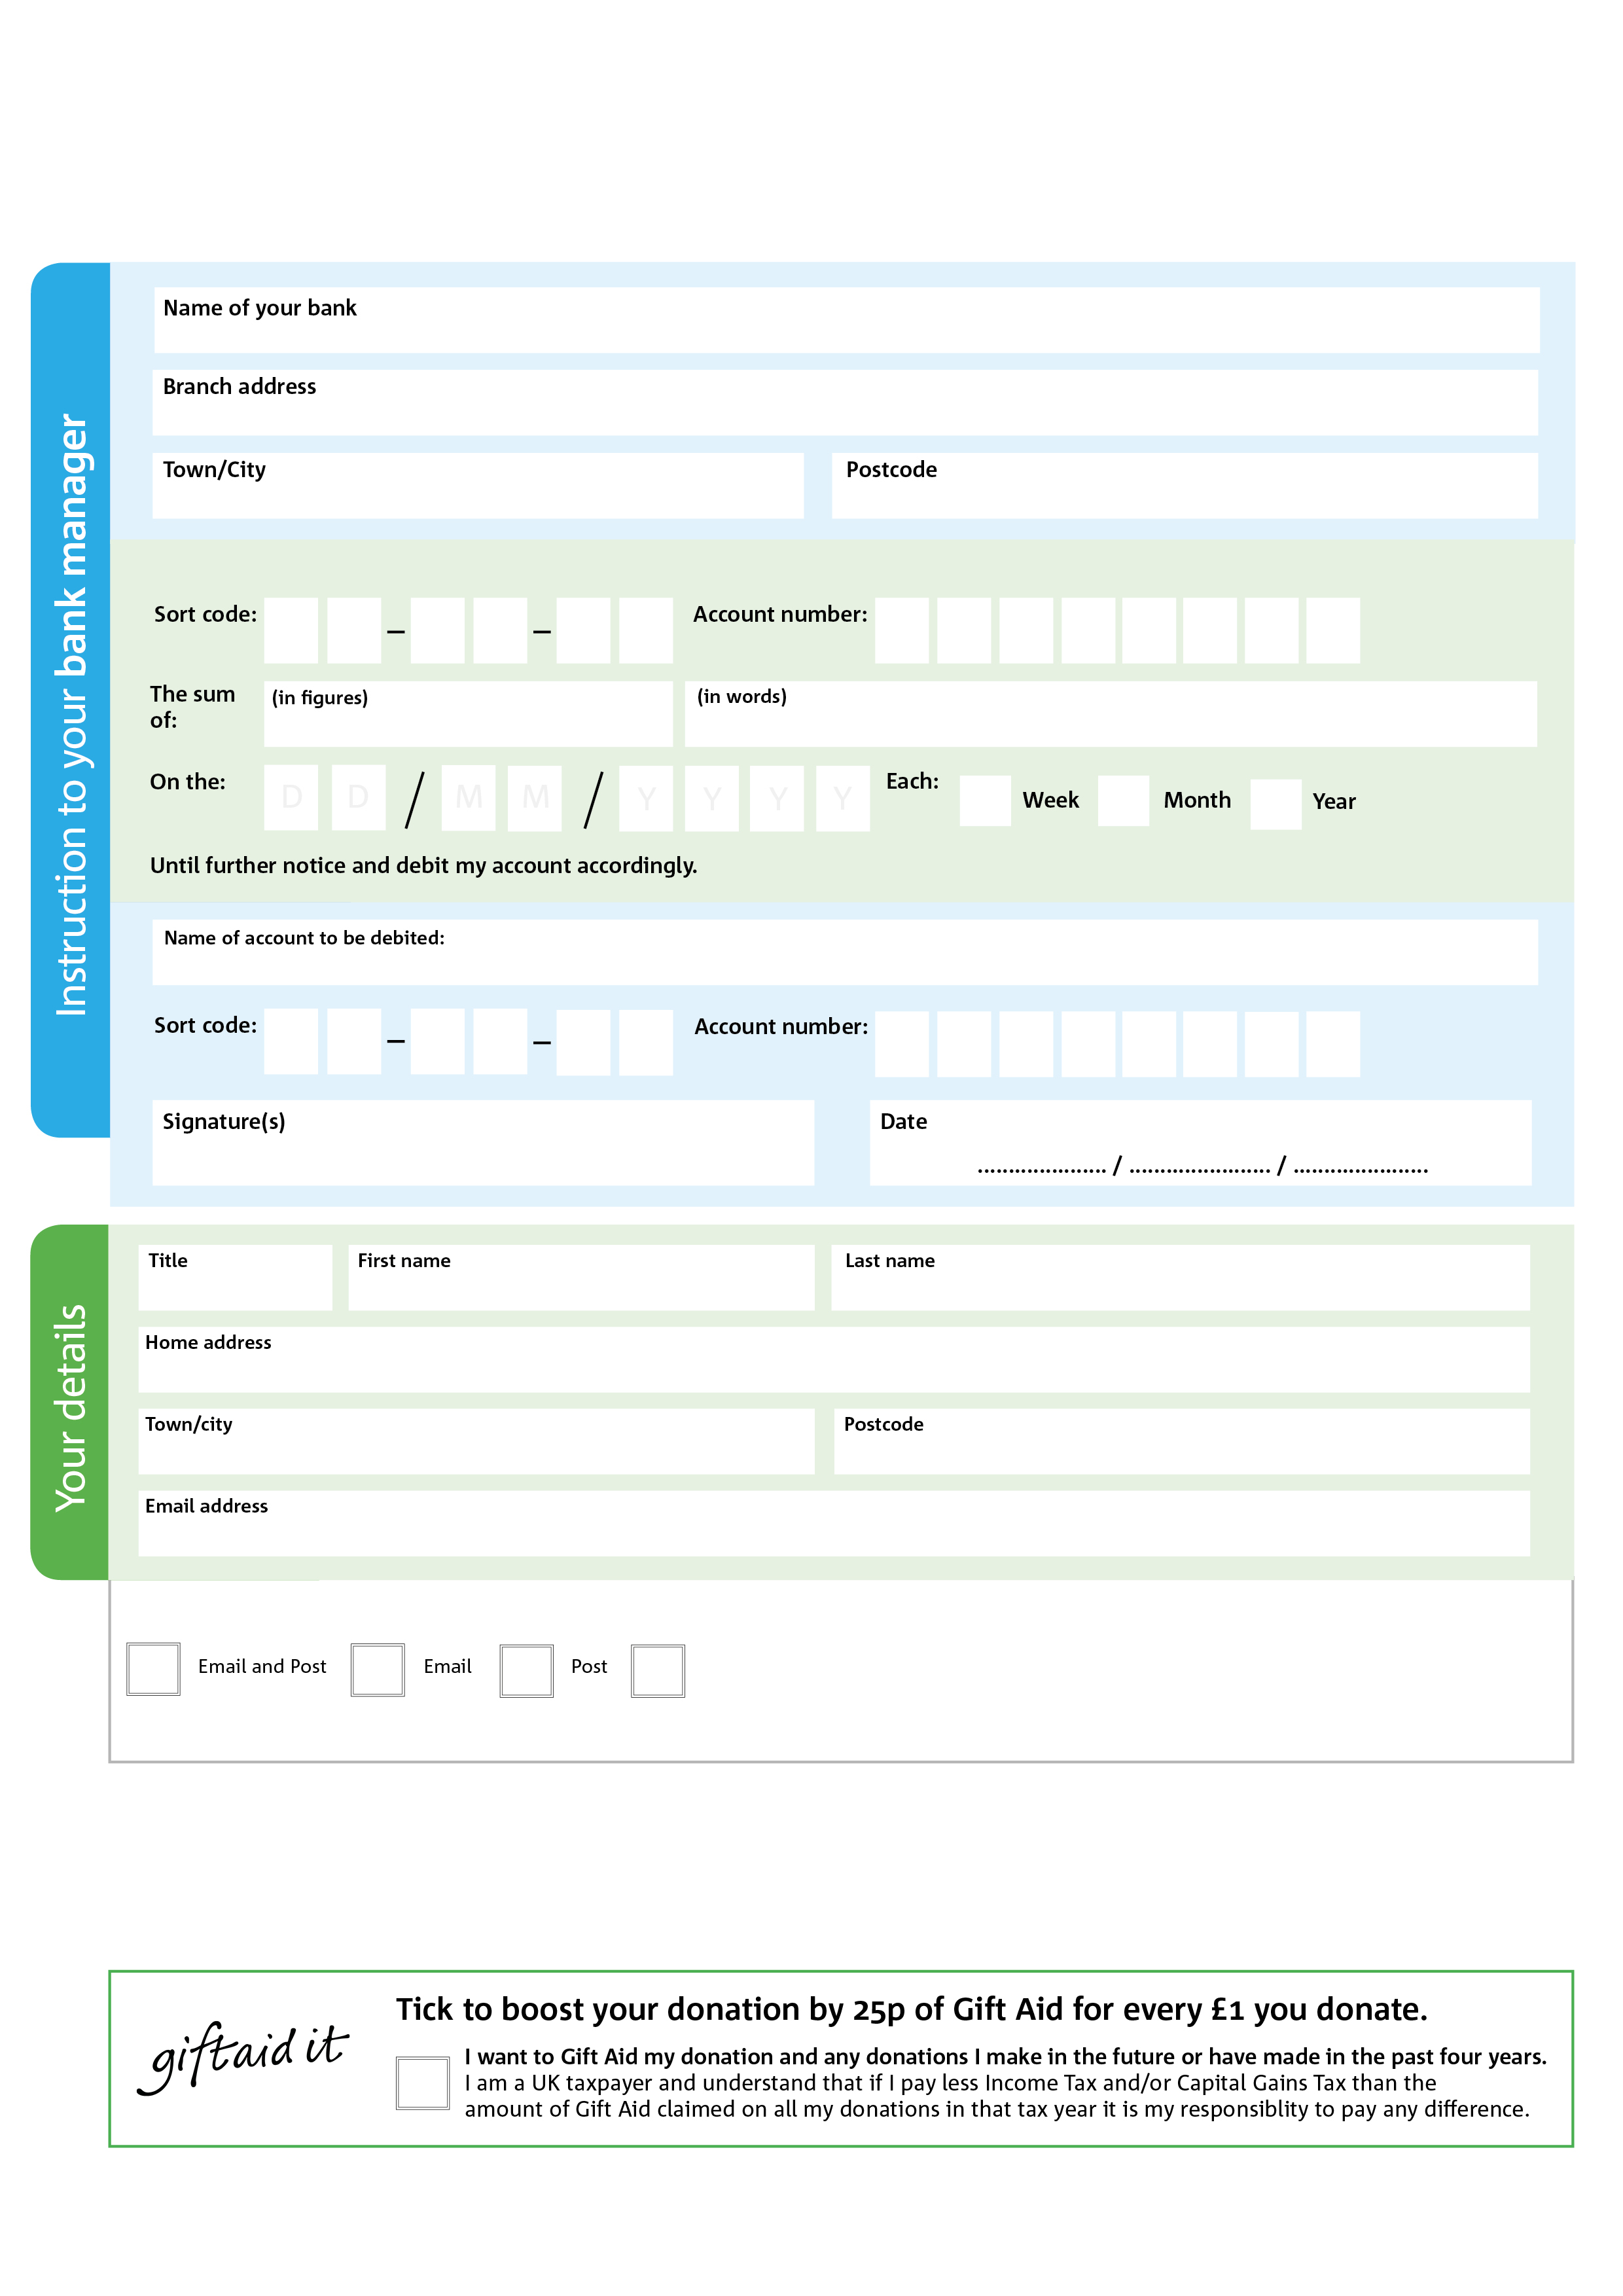

4X

V

3X

V

2X

V

6X

V

1X

V

0X

V

3X

V

7X

V

8X

5X

0X

60X

2X

0X

POSTAL ADDRESS: Chepstow Foodbank, C/O Unit 1a Critchcraft Buildings, Bulwark Industrial Estate, Bulwark, Chepstow NP16 5QZ

**Please pass this form onto the foodbank, using the foodbank’s address at the bottom, who will save a copy for their records. They will then send it onto your named bank or building society.**

We would love to keep you up to date with information about Chepstow Foodbank. Please tick your preference:

You can change your preferences any time by contacting us on 07931911869 or emailing us at info@chepstow.foodbank.org.uk

I do not wish to receive future communications from Chepstow Foodbank

Please pay Chepstow Foodbank,

**Data protection**

Chepstow Foodbank is committed to protecting your privacy and will process your personal data in accordance with the Data Protection Legislation. Chepstow Foodbank collects information to keep in touch with you and supply you with information relating to our work. To unsubscribe from our newsletter, send a message to the email address above with the word unsubscribe in the subject line. A full data privacy statement for financial donors is available from the foodbank on request.

**Standing Order Mandate**

**Chepstow.foodbank.org.uk**

Reg. Charity No: 1151076 | Reg. in England & Wales

You can change your preferences any time by contacting us on XXXXXXXXXXX or emailing us at XXXX@XXXXXXXXXX.foodbank.org.uk

I do not wish to receive future communications from XXXXXX Foodbank