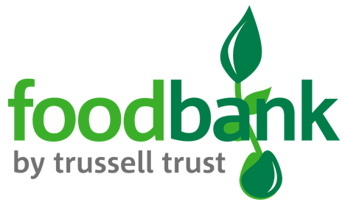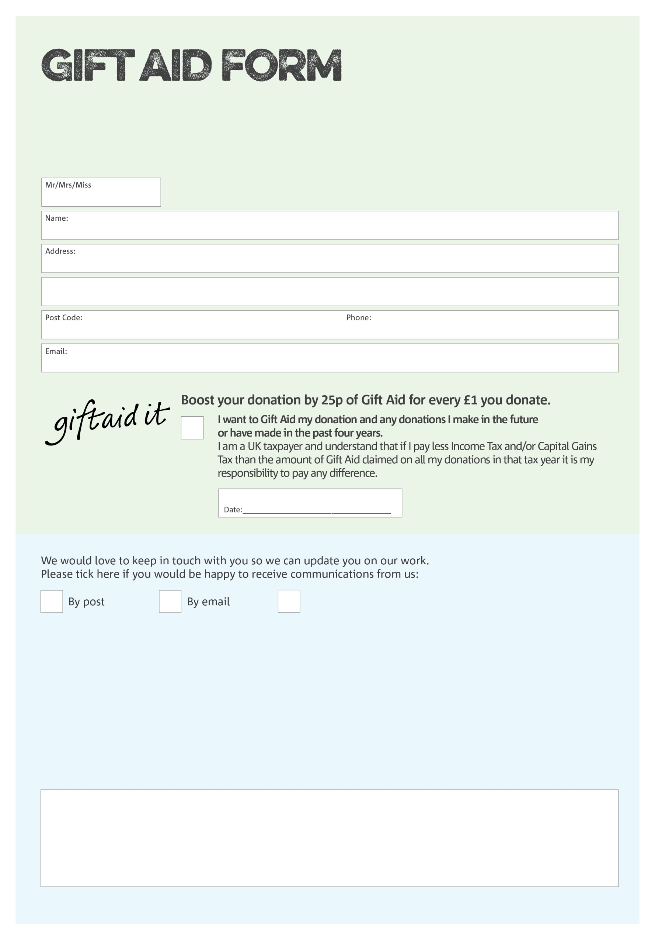

By filling in this form Chepstow Foodbank will receive an extra 25p for every £1 you give at no extra cost to you. Thank you!

You can change your preferences any time by contacting us on 07931911869 or emailing us at

info@chepstow.foodbank.org.uk

I do not wish to receive future communications from Chepstow Foodbank

**Data protection**

Chepstow Foodbank is committed to protecting your privacy and will process your personal data in accordance with the Data Protection legislation. Chepstow Foodbank collects information to keep in touch with you and supply you with information relating to our work. To unsubscribe from our newsletter, send a message to the email address above with the word unsubscribe in the subject line. A full data privacy statement for financial donors is available from the foodbank on request.

We would love to know why you have chosen to donate to Chepstow Foodbank. If you would like to share your motivation let us know below:

Charity Number 1151076. Registered in England and Wales